1. Release Notes
   1. Feature Comparison
   2. Version xx.xx.xx
2. Installation Instructions
   1. OS Compatibility
      1. Bot Designer:

|  |  |  |  |
| --- | --- | --- | --- |
| On Premise | GCP | MS Azure | AWS |
| Windows 10 / Windows Server 2012 R2 / Windows Server 2016 | Windows Server 2012 R2 Datacenter Core / Windows Server 2012 R2 Datacenter / Windows Server 2016 Datacenter / Windows Server 2016 Datacenter Core | Windows Server 2012 R2 Datacenter / Windows 10 Pro Ver 1809, 1803 / Windows Server 2016 Datacenter | Microsoft Windows Server 2016 Base/ Microsoft Windows Server 2012 R2 Base |

* + 1. Enterprise Manager Console:

|  |  |  |  |
| --- | --- | --- | --- |
| On Premise | GCP | MS Azure | AWS |
| Windows 10 / Windows Server 2012 R2 / Windows Server 2016 / Ubuntu 16.04 LTS / Red Hat Linux 7 | Windows Server 2012 R2 Datacenter Core / Windows Server 2012 R2 Datacenter / Windows Server 2016 Datacenter / Windows Server 2016 Datacenter Core / Ubuntu 16.04 LTS / Red Hat Linux 7 | Windows Server 2012 R2 Datacenter / Windows 10 Pro Ver 1809, 1803 / Windows Server 2016 Datacenter / / Ubuntu 16.04 LTS / Red Hat Linux 7.6 | Microsoft Windows Server 2016 Base/ Microsoft Windows Server 2012 R2 Base / Red Hat Enterprise Linux 8 |

* + 1. Worker:

|  |  |  |  |
| --- | --- | --- | --- |
| On Premise | GCP | MS Azure | AWS |
| Windows 10 / Windows Server 2012 R2 / Windows Server 2016 | Windows Server 2012 R2 Datacenter Core / Windows Server 2012 R2 Datacenter / Windows Server 2016 Datacenter / Windows Server 2016 Datacenter Core | Windows Server 2012 R2 Datacenter / Windows 10 Pro Ver 1809, 1803 / Windows Server 2016 Datacenter | Microsoft Windows Server 2016 Base/ Microsoft Windows Server 2012 R2 Base |

* 1. Minimum Hardware requirements

|  |  |  |  |  |  |
| --- | --- | --- | --- | --- | --- |
|  | **Bot Designer** | **Worker** | **Enterprise Manager Console** | **Microsoft SQL Server** | **PostgreSQL Server** |
| **Processor** | Intel Core i5 2.6 GHz | Intel Core i5 2.6 GHz | 8 core - 3.0 GHz Intel Xeon Platinum processor (Turbo Boost to 3.5 GHz) | 4 core Intel Xeon Processor | 2 core Intel Xeon Processor |
| **RAM** | 8 GB | 8 GB | 16 GB | 8 GB | 4 GB |
| **Storage** | 10 GB | 10 GB | 50 GB | 50 GB | 10 GB |
| **Network** | 1 GbE | 1 GbE | 10 GbE | 1 GbE | 1 GbE |
| **Other** | Microsoft .NET Framework 4.6 (Windows 8.1 and Windows Server 2012 R2: 4.6.1) | Microsoft .NET Framework 4.6 (Windows 8.1 and Windows Server 2012 R2: 4.6.1) | Microsoft .NET Framework 4.6 (Windows 8.1 and Windows Server 2012 R2: 4.6.1) | Microsoft SQL Server 2012 or later | PostgreSQL Server |

* 1. RPA Studio & Worker/Runtime

1. **How to download Techforce.ai RPA studio**

To download Techforce.ai RPA studio you need to click on below provided downloadable URL, the file size would be around 330 MB.

<https://github.com/digitamizers/techforce-ide/releases/download/v1.0.0-alpha.39/techforceide-install-v1.0.0-alpha.39.exe>

Click on the above URL to start downloading RPA studio.

1. **Installing RPA Studio**

To install RPA studio you need to have **945 MB** hard disk space in your machine.

After successfully downloading the RPA studio you can paste the downloaded studio .exe file in any of the folder if you want to move the file.

After moving the downloaded file, you need to right click on the installer and select “Run as administrator” so that RPA studio will have “Admin” privileges, below is an example image on how to run as administrator.

Windows will ask for permission stating “Do you want to allow unknown publisher to install the application” click on YES, so that the installation process will start.

You need to Agree the license agreement of Techforce.ai to proceed for further installation process.

As soon as you select/click on “I Agree” the installation process will take you to the folder selection screen.

**Note:** Here at the folder selection screen you need to select a folder in which the **folder name should not contain any space**, if you forget and select a folder which contains space in folder name then you cannot execute RPA scripts that you built using studio. So, click on Browse and select a folder which does not contain a space like shown in above image.

After selecting the folder, you can now click on “INSTALL” which will start installing RPA studio in your machine.

Installation will take a bit time, after installing the Studio click on close button to proceed for further process.

As soon as you click on close button, RPA studio installer will ask you to download a dependency file install the dependency file.

Click on “OK” button as shown in above image, so that you can install Techforce OCR which a dependency to RPA studio.

1. **Installing Techforce OCR**

To install Techforce OCR you need to have **164MB** of hard disk space. In the first screen of Techforce OCR installation it will ask you to select preferred language.

Select the preferred language and click on OK button, which will take you to the installation of Techforce OCR.

In the next screen of OCR installation click NEXT to continue the installation process.

You need to agree the license agreement of Techforce OCR to continue the installation process.

Now after agreeing to agreement, you need to specify/select the user level access I.E. to whom you want to give the OCR access. I.E “Anyone using this computer or Install just for me”.

Select any one of the options and click on NEXT button. In next screen you can choose the components that are to be installed or else you can just click on next which will continue the installation process.

After selecting the components installation process will take you to folder path selection, you can keep the default storage space or else you can also specify the installation folder.

You need to select the options for start menu action and then you can click on Install which will start the installation process.

Click on Install which will install Techforce OCR in your machine, after installation installer will ask you click on next button, and then click on “FINISH” button which will complete the RPA Studio Installation.

* 1. Enterprise Manger console

INSTALLING ORCHESTRATOR (WINDOWS OS)

* Installation documents will be provided by TechForce in zip files.
* databaseScripts, producer, receiver are zip files.
* Step1: In PRODUCER machine, unzip ‘databaseScript’ zip file.
* Step2: Open DBScripts file from above unzipped.
* Step3: Copy Scripts from either ‘MSSQL’ or ‘MYSQL’ as per your requirement/DB and Execute/RUN these scripts in your respective DB. (Paste in Query Editor & Execute/RUN it).
* Step4: Copy data in files TF_USER_LOGIN & TF_USER_TOKEN (unzipped from ‘databaseScript’) and paste in respective tables in DB.
* Step5: Now, UNZIP ‘producer’ file, in PRODUCER machine.

# INSTALLING ORCHESTRATOR IN PRODUCER MACHINE:

To install Orchestrator successfully in your local machine below mentioned software’s should be installed.

1. Erlang
2. Rabbit MQ
3. Hashi corp vault
4. Node JS
5. Yarn.

## Erlang:

To install Erlang in your machine you need to go to the URL specified.

<https://www.erlang.org/downloads> (or the same file is unzipped from ‘producer’ file provided by TechForce)

Click on “[OTP 21.2 Windows 64-bit Binary File](http://erlang.org/download/otp_win64_21.2.exe)“which will download the installer, now navigate to downloaded path and install Erlang in your machine.

Before we continue, ensure that the appropriate environment variable (ERLANG_HOME) has been created during the installation. If, for any reason, the environment variable is missing, you will need to create it manually as per the image below:

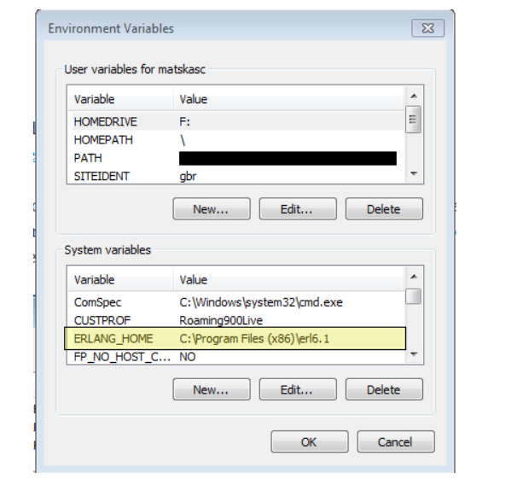

## Rabbit MQ:

To install Rabbit MQ in your machine you need to go to the URL specified.

<https://www.rabbitmq.com/download.html> (or the same file is unzipped from ‘producer’ file provided by TechForce)

After opening the URL click on “Windows Installer”, which will start downloading Rabbit MQ.

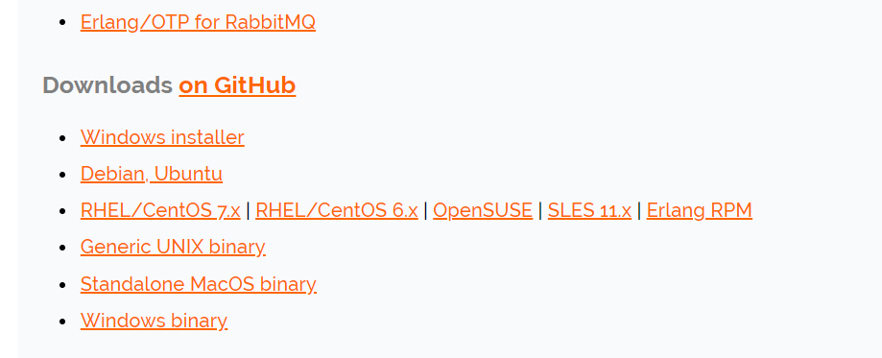

Now open the downloaded folder and double click on Rabbit MQ installer which will pop-up a screen as **“Do u wan to allow this app from an unknown publisher”** click **“YES”.**

Click “NEXT” at “choose components” step.

At “Choose Installation Location” you can browse your specified location to install Rabbit MQ or Click “INSTALL”.

Open an elevated command line (Run as Administrator)

Navigate to the sbin directory of the RabbitMQ Server installation directory. In my case the path is C:\Program Files (x86) \RabbitMQ Server\rabbitmq_server-3.3.4\sbin copy the path and paste it in the “PATH” variable in “SYSTEM VARIABLES” under “ENVIRONMENT VARIABLES”.

Open command prompt from “C:\Program Files (x86) \RabbitMQ Server\rabbitmq_server-3.3.4\sbin” path and run the below command to start/run Rabbit MQ plugin.

Run the following command to enable the plugin **rabbitmq-plugins.bat enable rabbitmq_management**

1. Navigate to C:\Users\<currentLoggedInUser>\AppData\Roaming\RabbitMQ
2. Create a new file rabbitmq.config paste the following data

[{rabbit,

[{heartbeat, 0}]

}].

1. Open Advanced.config from the same folder Remove the data and Paste the following data and save it

[{rabbit,

[{heartbeat, 0}]

}].

1. Open an elevated command prompt (run as administrator type) paste the following commands
   1. rabbitmq-service.bat stop
   2. rabbitmq-service.bat remove
   3. rabbitmq-service.bat install

5. Start the rabbitMQ service using the following command

**rabbitmq-service.bat start**

## Hashi corp vault

To download Hashi corp vault in your machine you need to go to the URL specified.

<https://www.vaultproject.io/downloads.html> (or the same file is unzipped from ‘producer’ file provided by TechForce))

Above URL will download a .zip file which you need to extract and navigate to the extracted folder and copy the folder path and set that at “PATH” in “ENVIRONMENT VARIABLES”. Below is my folder path.



To Navigate to environment variables, try the below option.

Right click on “My computer/This PC”, click “Properties”, Click “Advance system settings”, Click “Environment Variables”.

Now paste previously copied “Hashi corp vault” path in “PATH” variable under “System variables”.

### Starting hashi corp vault:

* 1. Create a folder anywhere to store your secret data
  2. Copy the folder path
  3. Create a file config.hcl
  4. Paste the below content in the config.hcl file

disable_cache = true

disable_mlock = true

ui = true

listener "tcp" {

address = "127.0.0.1:8200"

tls_disable = 1

}

storage "file" {

path = "E:\\Vault\\FileSystem"

}

* 1. Replace the yellow highlighted part with the path of folder created in step one
  2. Set two system environment variables
     + VAULT_ADDR = <http://127.0.0.1:8200>
     + VAULT_API_ADDR = <http://127.0.0.1:8200>

#### Starting the vault server

With the configuration in place, starting the server is simple, as shown below. Modify the -config flag to point to the proper path where you saved the configuration above.

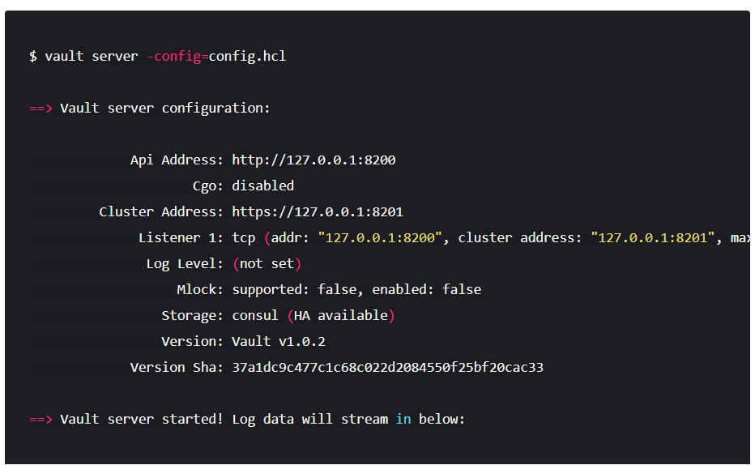

#### Initializing the vault’

Initialization is the process configuring the Vault.

During initialization, the encryption keys are generated, unseal keys are created, and the initial root token is setup. To initialize Vault use **vault operator init** in a new command prompt

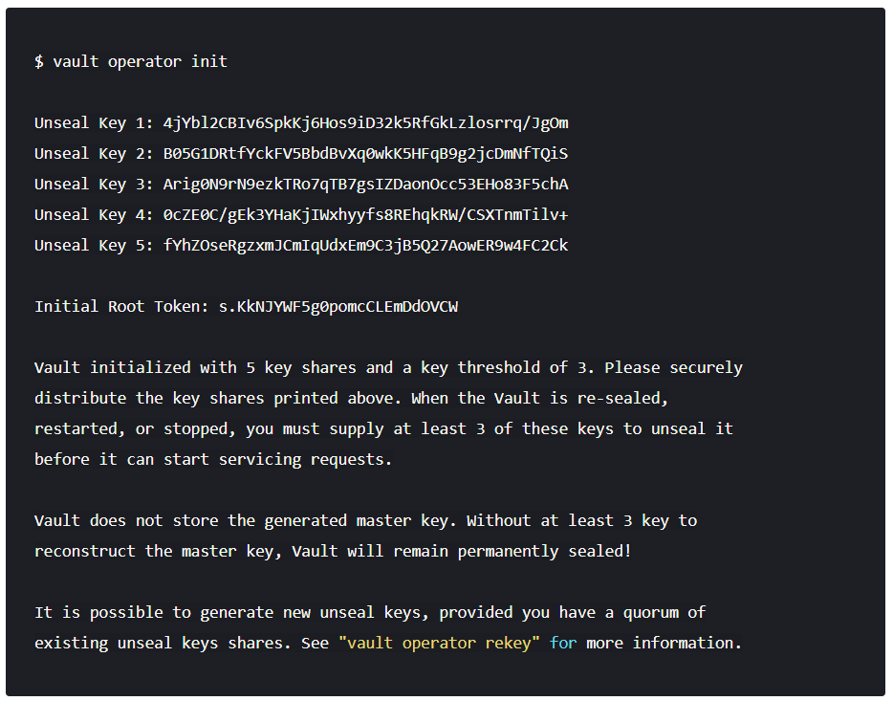

Initialization outputs two incredibly important pieces of information: the unseal keys and the initial root token. This is the only time ever that all of this data is known by Vault, and also the only time that the unseal keys should ever be so close together.

Save the above 5 unseal keys and initial root token in a file for future use.

#### Unseal Vault

Every initialized Vault server starts in the sealed state. From the configuration, Vault can access the physical storage, but it can't read any of it because it doesn't know how to decrypt it. The process of teaching Vault how to decrypt the data is known as unsealing the Vault.

Unsealing has to happen every time Vault starts. It can be done via the API and via the command line. To unseal the Vault, you must have the threshold number of unseal keys. In the output above, notice that the "key threshold" is 3. This means that to unseal the Vault, you need 3 of the 5 keys that were generated.

Begin unsealing the Vault:

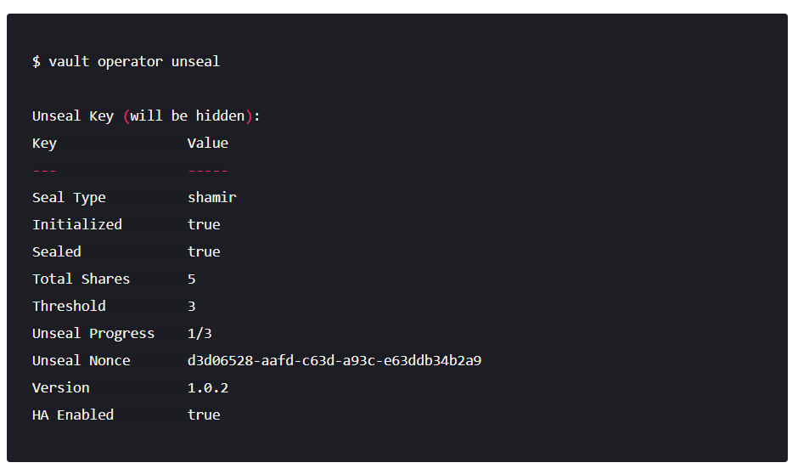

After pasting in a valid key and confirming, you'll see that the Vault is still sealed, but progress is made. Vault knows it has 1 key out of 3. Due to the nature of the algorithm, Vault doesn't know if it has the correct key until the threshold is reached.

Also notice that the unseal process is stateful. You can go to another computer, use vault operator unseal, and as long as it's pointing to the same server, that other computer can continue the unseal process. This is incredibly important to the design of the unseal process: multiple people with multiple keys are required to unseal the Vault. The Vault can be unsealed from multiple computers and the keys should never be together. A single malicious operator does not have enough keys to be malicious.

Continue with vault operator unseal to complete unsealing the Vault. To unseal the vault, you must use three different keys, the same key repeated will not work. As you use keys, as long as they are correct, you should soon see output like this:

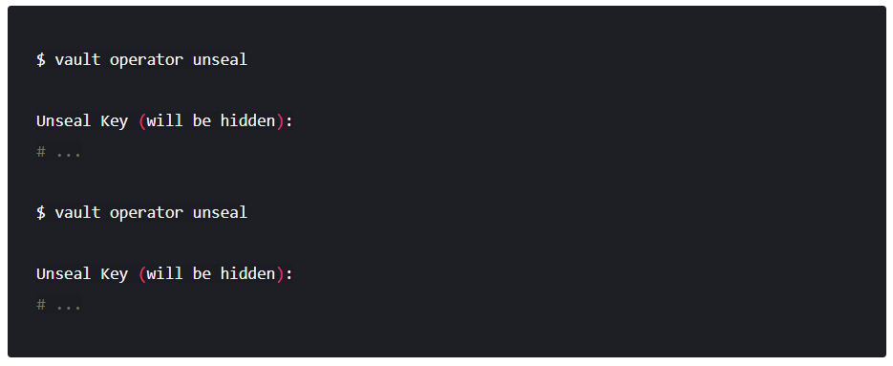

When the value for Sealed changes to false, the Vault is unsealed:

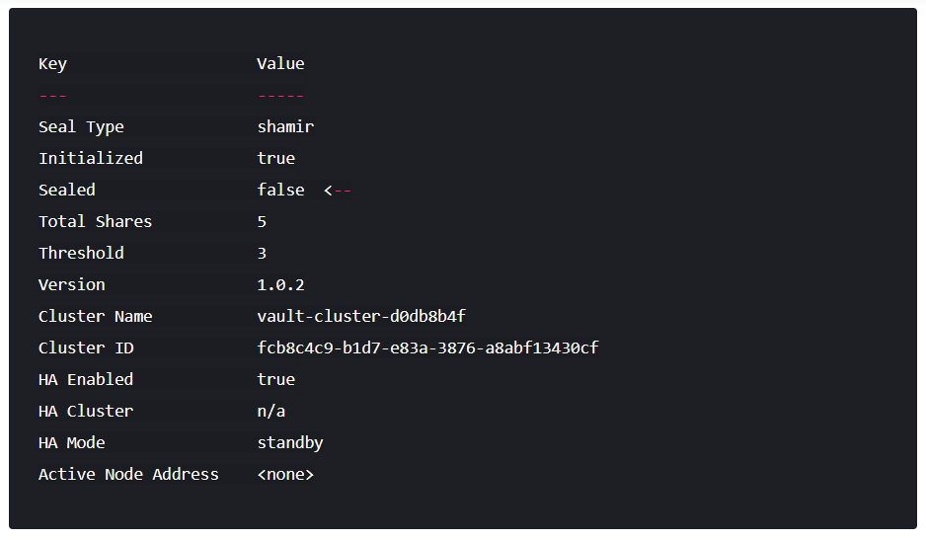

Finally, authenticate as the initial root token (it was included in the output with the unseal keys):

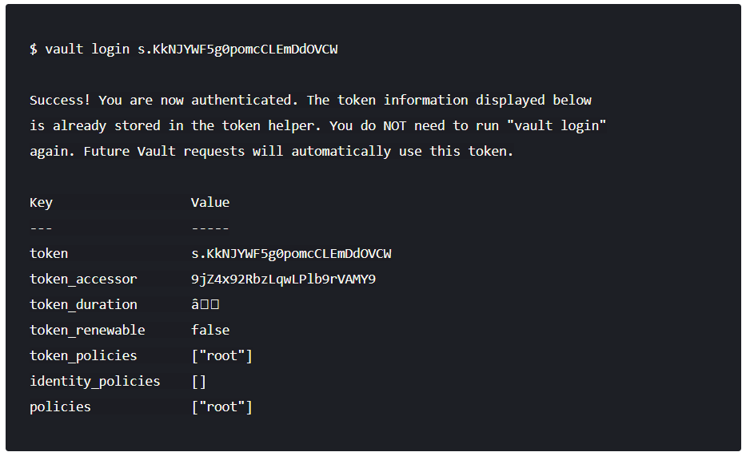

Navigate to ENVIRONMENT VARIABLES below are the steps on how to navigate to environment variables

Right click on “My computer/This PC”, click “Properties”, Click “Advance system settings”, click “Environment Variables”, Create a new variable as “**VAULT_DEV_ROOT_TOKEN_ID**” and value as initial root token value.

## Node JS:

To download Node JS in your machine you need to go to the URL specified.

<https://nodejs.org/en/download> (or can be unzipped from ‘producer’ file provided by TechForce)

After completion of downloading, install node js.

Now you also need to download “YARN” in your machine, to download YARN type below mentioned command in command prompt.

**“npm install -g yarn”**

## Open firewall port 5672

You can manually permit a program to access the internet by opening a firewall port. You will need to know what port it uses and the protocol to make this work.

1. Navigate to Control Panel, System and Security and Windows Firewall.
2. Select Advanced settings and highlight Inbound Rules in the left pane.
3. Right click Inbound Rules and select New Rule.
4. Add the port you need to open and click Next.
5. Add the protocol (TCP or UDP) and the port number-5672into the next window and click Next.
6. Select Allow the connection in the next window and hit Next.
7. Select the network type as you see fit and click Next.
8. Name the rule something meaningful and click Finish.

## Start the servers

1. Set a system variable **REACT_APP_IPADDRESS**, **local iP** (public ip for vm) as its value.
2. Open 3 different command prompts. Navigate to the Orchestrator_API, RPA_authentication, and RPAWebapp (unzipped content from producer.zip file) paths from the 3 terminals.
3. Type the following commands in each terminal
   1. npm install
   2. npm start

## Configure Database

1. Open browser
2. Open <http://localhost:4050> or http://<localIP>:4050 or http://<publicIP>:4050 (for VM)
3. You will be redirected to a Db credentials Page.
4. Select your Database (Dialect) - mysql or mssql
5. Fill all the fields and submit
6. You will be redirected login Page.
7. Login to your account using the credentials given below
   1. Username: techforce
   2. Password: Welcome

# Receiver Installation

1. Install nodejs and python 3.6 or above
2. Unzip the receiver.zip file.
3. Copy the path of Techforce/src/flows (unzipped receiver file) and set it to a system variable TECHFORCE_HOME
4. Copy the path of Techforce-windows/src (unzipped receiver file) and add it to the PATH variable under system variables
5. Open a command prompt navigate to Orchestrator_receiver (unzipped receiver file) and run the below commands
   1. npm install
   2. node index.js
6. Open another command prompt navigate to Orchestrator_python_api (unzipped receiver file) and run the below commands
   1. pip install –r requirements.txt
   2. python manage.py runserver 0.0.0.0:8000
   3. Load Balancer requirements
   4. Deployment options (Single Thread or Multi Thread)
7. Architecture overview & Deployment Models
   1. Enterprise Model

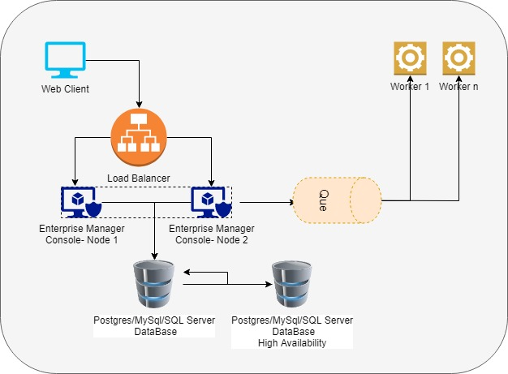

* 1. Hybrid Model

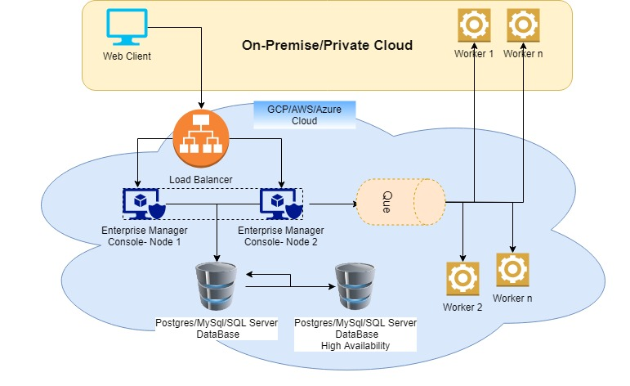

* 1. SaaS/PaaS Model

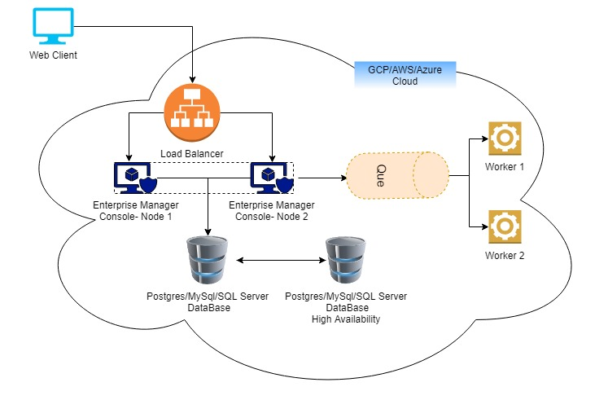

1. Design a Bot – Best practices & guidelines
2. Enterprise Manager Console – Management Guide
   1. User Management
   2. Schedule Management
   3. Worker Management
   4. Log Management
   5. Vault Management
3. Developer Guide
   1. Getting Started
   2. Build Basic Bots
   3. Build Advanced Bots
4. Security Architecture
5. Troubleshooting Guide
6. Analytics